Object Detection Model
Project 7/8

Tom Heijmans (1079471)
Sandra Hekkelman &
Wouter Volders
Eerste gelegenheid
7/6/2026
Literature Research Rapport
-
Table of Contents
Summary 3
Introduction 3
Method 3
Results 4
Conclusion 5
Glossary 6
Sources 6
Changelog 6

Summary
// TO-DO

Introduction
Our project is the development of software to make a small kart drive autonomously. This is for the SDC (Self-Driving-Challenge) provided by the RDW (Rijksdiest voor het Wegverkeer) to give them more insight into how self-driving vehicles work, since some of the car companies developing this software don’t want to give away their development procedures.
To have the kart drive autonomously it must be able to detect things that are on the road ahead of it, these things include: People, Cars, Traffic Signs and Traffic Lights. The Detection will be done through camera’s and an Object Detection Model, but then the question is: Which Object Detection Model is the most applicable? That is the question that will be covered in this rapport.

Method
The Research method of this rapport is literary research. That means that this rapport will be done through sources of the documentation of various different model types.
There are some requirements for choosing the right/most applicable detection model:
- Latency; the model has to work mostly in real time (<= 1 second).
- Accuracy; the model has to be able to reliably detect objects and has to work on smaller/further objects.
- Load; the model has to remain lightweight. The heavier models increase CPU usage, which can cause frame-skipping, which in turn can cause missed detections. Load in this context stands for Computational Load.
- Trainability; since the model has to detect
  - Signs (Stop, Speed, Prohibited, Directional (one-way), Mandatory),
  - Pedestrians,
  - Vehicles (Cars),
  - Traffic Lights.
The model has to at least be able to detect these object types and their subcategories. Because of that is important for the model to be trainable.

Results
For this research rapport a comparison is made between models from documents and datasheets of these models. The models I will be comparing are the YOLOv8, YOLOv26, SSD and Faster R-CNN models. These models were found in [1], which gives a list of commonly used object detection models that provide a good overview of the trade-offs. Based on the requirements defined in the Method section, the object detection models are compared using the information gathered from official documentation, benchmark reports and research papers.
This comparison is mainly focused on four factors: Latency, Accuracy, Load and Trainability. The results from this comparison are shown in the next table.
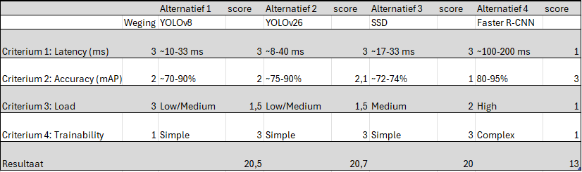
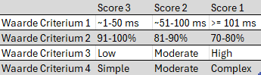
*table made with information from [2] -> [6]
From the results you can gather that all of the models are capable of real-time detection (under 1000 ms).
However the two YOLO models show the lowest numbers of latency, which makes them suitable for applications where fast detection is required. The YOLO models are one-stage detectors and have a relatively high accuracy and low load on the system. The simple trainability of the YOLO models is also good to have available.
The SSD model, like the YOLO models, is also a one-stage detector. It has a relatively low latency, whilst also having a lower accuracy, and a higher load on the system. The trainability is also simpler.
The Faster R-CNN model is a two-stage detector. It has the best accuracy, but has a signicanty higher Latency and Load on the System, whilst also having a Complex method of trainability, which makes it less suitable for our application..
The difference between one-stage detectors and two-stage detectors is that whilst one-stage detectors use a CNN (convolutional neural network) to directly predict the bounding box coordinates, and class probabilities from the input images in one pass, two-stage detectors splits the task into two steps: Region Proposal and Region Classification/Refinement. Region Proposal identifies potential areas and separates these whilst Region Classification classifies and tightens these bounding boxes for a higher accuracy [7].
Put into simple terms, being a one-stage detector means that it is faster and lighter load, but less accurate. Being a two-stage detector means that it is more accurate, but slower, and a higher load.
Overall the results point that one of the YOLO based models provide the best balance between latency, accuracy, load, and trainability for the set requirements defined in the method of this research. Whilst the SSD model has a lower accuracy and the Faster R-CNN model has a very high latency, compared to the other 3 models.

Conclusion
To answer the question that was asked in the introduction, which was “Which Object Detection Model is most applicable?”, from the results of this rapport, it can be concluded that a YOLO-based model wil be used. This is because it fits the defined requirements. It has a low latency whilst providing a decent accuracy. It also has a relatively low load, and a simple trainability.
SSD has a relatively low latency, but also has a lower accuracy. Since the model has to detect objects and detect them accurately, it would be bad for the model to not detect something critical, like a person. That’s why we wont be using the SSD model.
The Faster R-CNN model is more accurate, but this comes at the (very high) cost of latency. Whilst it is better to have it detect objects and obstacles more accurately, it is not good if it comes at the cost of the ability to detect those in real time. The load is also higher than the YOLO models, which is also not good for the system.

Glossary
mAP Mean Average Precision. Shows how precise the model is on average (in %).
Latency The Delay between the time that the object is shown and actually detected.
Computational Load The amount of processing power something takes to run.

Sources
[1] https://encord.com/blog/object-detection/ (MODELS)
[2] https://docs.ultralytics.com/models/yolov8/ (YOLOv8)
[3] https://arxiv.org/pdf/2305.09972 (YOLOv8)
[4] https://docs.ultralytics.com/tasks/detect/#models (YOLOv26)
[5] https://arxiv.org/pdf/1512.02325 (SSD)
[6] https://tensorblue.com/blog/object-detection-yolo-faster-rcnn-real-time-detection-2025 (YOLO & faster R-CNN)
[7] https://www.ultralytics.com/blog/what-is-r-cnn-a-quick-overview (R-CNN)

Changelog
Version | Changes | Date
0.1 | Document Made | 19-2-2026
1.0 | Document Version 1 Written and Finished | 13-3-2026

